Materials Science Colloquia
Physics Department
University of Rome Tor Vergata
(webinars on the Zoom platform)
Organizers : Maurizia Palummo , Luca Camilli

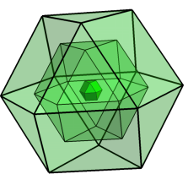
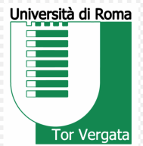

Maurizio Passacantando
Dipartimento di scienze fisiche e chimiche, Università dell’Aquila
Title “Chemical vapor deposition growth of carbon nanotubes: characterization and applications” 6 November 2020, 3.00pm

Liv Hornekær
Department of Physics and Astronomy & interdisciplinary Nanoscience Center- iNANO, Aarhus University, Denmark
Title “Engineering the Electronic and Chemical Properties of Graphene via Functionalization and Intercalation”
16 November 2020, 3.30 pm

Nicola Marzari
École Polytechnique Fédérale de Lausanne, Switzerland
Title “The great acceleration in the design and discovery of novel materials”
14 December 2020, 3.30 pm

Jani Kotakoski
Faculty of Physics, University of Vienna, Austria
Title “Atomic-scale manipulation of 2D materials”
20 January 2021, 3.30 pm

Stephan Hoffman
Division of Electrical Engineering, University of Cambridge, the United Kingdom
Title “Integrated Crystal Growth of Advanced Nanomaterials: from model systems to integrated manufacturing”
11 February 2021, 3.30 pm

Jeffrey C. Grossman
Department of Materials Science and Engineering, Massachusetts Institute of Technology, Massachusetts, USA
Title “Materials Innovation for Energy and Water”
18 March 2021, 3.30 pm

Marco Bernardi
Applied Physics and Materials Science, Caltech Institute of Technology, California, USA
Title “Electron dynamics in materials from first principles”
15 April 2021, 4.00 pm

